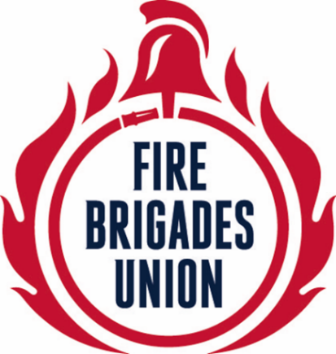

THE FIRE BRIGADES UNION

CONFERENCE 2017

PROPOSED AMENDMENTS TO THE
EXECUTIVE COUNCIL POLICY STATEMENTS
ON

- APPRENTICESHIPS IN THE FIRE AND RESCUE SERVICE (pages 2 & 3)
- THE TRADE UNION ACT (page 4)

MOVED BY
BRIGADE COMMITTEES

PROPOSED AMENDMENTS TO THE
EXECUTIVE COUNCIL POLICY STATEMENT
ON

APPRENTICESHIPS IN THE FIRE AND RESCUE SERVICE

MOVED BY
BRIGADE COMMITTEES

AMENDMENT 1
On page 2, third paragraph, delete ‘NI’ and replace with ‘Northern Ireland’

On page 3, second bullet point, delete ‘in’ immediately after ‘taking’

On page 3, final paragraph, after ‘provided with high quality training’, insert ‘and the best possible conditions of service’

On page 3, final paragraph, delete ‘other than for reasons of poor performance’

On page 7, final bullet point, delete ‘and’ immediately before ‘FRS’ and replace with ‘an’
LONDON

AMENDMENT 2
4th bullet point under “Principles For An FBU Position On Fire Service Apprenticeships”

Delete “10pm and 6am” replace with “7pm and 8am”
SHROPSHIRE

AMENDMENT 3
13th bullet point under “Principles For An FBU Position On Fire Service Apprenticeships”

Delete “We should aim for the”
SHROPSHIRE

AMENDMENT 4
Final bullet point in document

Delete “by and FRS will” replace with “by FRSs will”
SHROPSHIRE

PROPOSED AMENDMENT TO THE
EXECUTIVE COUNCIL POLICY STATEMENT
ON

THE TRADE UNION ACT

MOVED BY
BRIGADE COMMITTEES

AMENDMENT 1
On first line of fourth paragraph, delete “a one year transition period for”

SHROPSHIRE

