«NameLine1» «RegionBrigade» «StationCode»
«OtherName»
«Address1»
«Address2»
«Address3»
«Address4»
«Address6»

Circular: 2020HOC0418MW

Date: 17 July 2020

To: All Members

Dear Brother/Sister

Pensions: Age discrimination case update

The FBU won a significant victory on pension provision for members who were discriminated against on the grounds of their age in relation to the transitional protection introduced following the imposition of new pension schemes in 2015.

The interim declaration made in December 2019 means that affected members are eligible to be treated as if they are still members of their previous pension scheme.

Despite this declaration, we are well aware firefighters are still facing problems relating to both ordinary and ill-health retirements and how they can access the benefits to which they are entitled. The FBU has raised concerns locally and nationally about this and has now put out a call for test cases from members, as the union prepares to take legal action to resolve the delay.

The union is also seeking to progress claims relating to:

- Reimbursement of any out-of-pocket losses members may have suffered as a result of the changes made in 2015.

- Compensation for members for the distress, upset and anger – described by lawyers as “injury to feelings” – that may have been caused.

Over 13,500 members have submitted new online claims as part of this process.

Government consultation

In the meantime government has been preparing a proposal to address the need to provide a remedy in relation to the discriminatory nature of their transitional protection arrangements. This is a direct result of the age discrimination victory won by the FBU.

Contd/2….

-2-

A further hearing in our legal process had been planned to take place on 17 July 2020. However, this was stayed as a result of separate legal matters involving the fire service employers. This means that the interim position remains unaltered.

In addition to this the formal consultation on their proposals for removing the age discrimination were issued yesterday and will run until Oct 2020. This consultation makes clear that it seeks to address the issue of discrimination for all the main public sector schemes (apart from the local government scheme).

The union is currently assessing the consultation document and will issue further detail shortly. The proposals in the consultation include providing affected members with a choice regarding which scheme benefits they would access for the relevant period. The FBU has already been discussing the two approaches as part of the informal consultation – immediate and deferred - and the early indications suggest that the majority of members would be best served by the deferred option.

Please note that this is a significant document that will need to be carefully considered before a formal response to the consultation can be agreed. We will be considering it in detail over the next few weeks and a response will be prepared. This will include taking any legal and actuarial advice. In addition to this the FBU will be looking at whether or not there is a need for, or possibility of, any additional legal challenges.

Members will be updated on issues during this time as more information becomes available.

Valuations of 2015 scheme – pause on cost control mechanism and potential improvement to member benefits

The FBU also initiated a further legal challenge against the government decision to pause the remedy to increase benefits for 2015 scheme members.

The need for improved benefits was highlighted by the recent valuation of firefighter pension schemes. The valuation showed that the costs of the schemes were below the agreed cost floor. This should have automatically triggered a mechanism for improving member benefits.

However, the Government paused the process for making these improvements following our separate legal victory on age discrimination. This decision – to pause the process and delay improvements to benefits - was challenged by the FBU and other unions who supported as interested parties.

The Government have recently announced that they will be unpausing the process. However, they state that they intend to now take into account the cost of the proposals to remedy age discrimination.
This is an unacceptable approach that means that government are seeking to amend (reduce) improvements to members’ benefits in the 2015 scheme so as to pay for the government’s unlawful discrimination against former members of the 1992 scheme. This is an unjust and unacceptable approach and we are currently exploring ways to challenge it further.

Best wishes.

Yours fraternally

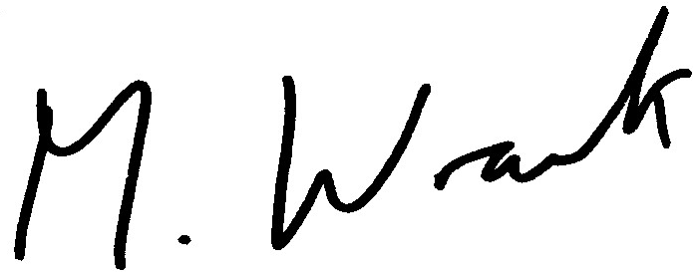

Matt Wrack
General Secretary

MW/sll

