Circular: 2019HOC0305MW

«NameLine1» «RegionBrigade» «StationCode»
«OtherName»
«Address1»
«Address2»
«Address3»
«Address4»
«Address6»

DATE: 13 June 2019

TO: ALL MEMBERS - SCOTLAND

Dear Brother/Sister,

SCOTLAND: FIREFIGHTERS’ PAY PROPOSAL

The Scottish Regional Committee met today to discuss the proposal received from the Scottish Fire and Rescue Service in relation to pay.

This meeting was attended by FBU General Secretary Matt Wrack and President, Ian Murray, to provide updates from the recent pay negotiations with SFRS and to report the Executive Council response to the SFRS pay proposal.

The Executive Council unanimously agree that the proposal, in its current form, cannot be accepted.

Following today’s meeting, the Scottish Regional Committee unanimously agreed with this position, that the current proposal cannot be accepted.

The proposal is vague, lacking in detail and there are significant concerns over the FBU being excluded from negotiating any future policies or process underpinning this proposal. In addition, the loss of CPD and ARA detailed within this final offer, renders us unable to recommend acceptance to our members.

The FBU will now be commencing meetings throughout Scotland as a matter of urgency to fully update and consult members, through our structures, on the situation. This will also give our members the opportunity to ask any questions.

The FBU remains willing to engage in further negotiations with the SFRS to reach a position whereby we can recommend acceptance of the proposal to our members.

Full details of the SFRS proposal can be found on the FBU National Website www.fbu.org.uk

Yours fraternally
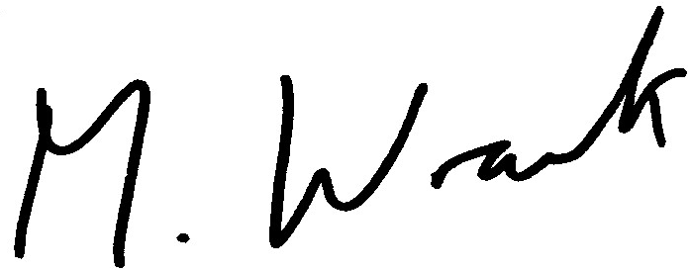

MATT WRACK
General Secretary

MW/kd

