Circular: 2018HOC0471MW

20 September 2018

TO: All Members

Dear Brother / Sister

Pay Discussions: Members’ Consultation

The Executive Council heard report-backs this week following a consultation with members across the union on the issue of pay, as set out in All Members circular 2018HOC0382MW of 27 July.

The Fire Service Employers had proposed that pay (including CPD) should be “uplifted by 2.0% with effect from 1 July 2018 while negotiations continue to put in place a longer term deal”.

Taking account of the members’ consultation, the Executive Council agreed that this “uplift” should be applied. The Fire Service Employers have been informed of this.

New pay rates will be issued in due course.

Best wishes.

Yours fraternally

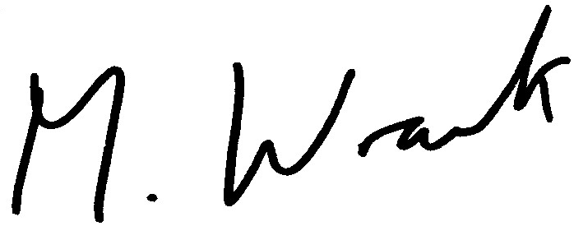

Matt Wrack
General Secretary

MW/sll

