Circular: 2018HOC0342MW

«NameLine1» «RegionBrigade» «StationCode»
«OtherName»
«Address1»
«Address2»
«Address3»
«Address4»
«Address6»

27 June 2018

TO: All Members

Interim Agreement in West Midlands and Cancellation of Planned Strike Action

I am pleased to be able to tell you that on Monday this week, and in consultation with local FBU officials, I authorised the signing of an interim agreement (which is a collective agreement) which represents significant progress in resolving some of the issues of our trade dispute in the West Midlands. The agreement was reached using the National Joint Council (NJC) mechanisms for assisting local parties. It covers various areas of the trade dispute including, most significantly in relation to national issues, the issue of contracts of employment for new joiners to the service.

Strike action had been planned to take place on 30 June 2018 and 4 July 2018 and was subsequently cancelled. The trade dispute is not resolved and it has been agreed with the West Midlands Fire Service that further talks will take place to try to find a resolution to the trade dispute in its entirety. Further strike action may be called in the future. We obviously hope to be able to avoid this.

This breakthrough is as a result of the campaigning work of FBU members and officials locally and of the unity and solidarity of all West Midlands members in producing a remarkably high turnout and vote for strike action. They should all be congratulated for such a strong result. It has undoubtedly assisted us immensely in the discussions which followed.

The issues raised by the West Midlands dispute have clear implications for us all nationally. In particular, it raised the issue of whether firefighters will work under contracts of employment negotiated through collective bargaining or will face the imposition of working arrangements unilaterally by employers. In this context, our West Midlands members have been fighting a campaign on behalf of everyone. We hope other employers will take note. The FBU will defend collective bargaining and negotiation rights at national and local level – by any means necessary.

I am sure you will join me in thanking FBU members and officials in the West Midlands for the work they have carried out that has resulted in this achievement.

Best wishes.

Yours fraternally
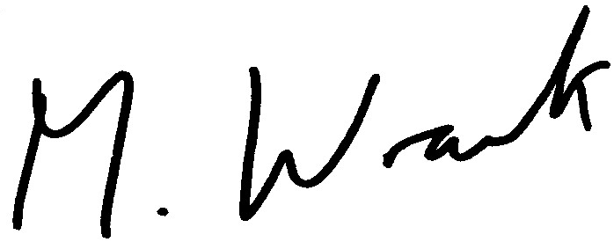

MATT WRACK
General Secretary

