Circular: 2018HOC0292MW

«NameLine1» «RegionBrigade» «StationCode»
«OtherName»
«Address1»
«Address2»
«Address3»
«Address4»
«Address6»

To: All Members West Midlands

Dear Brother/Sister
BALLOT RESULT
Please note that the result of the ballot as to whether members of the FBU are prepared to take part in industrial action consisting of a strike in relation to the trade dispute is as follows:

Number of individuals who were entitled to vote in the ballot: 1170
Number of votes cast in the ballot: 954
Number of individuals answering “yes” to the question: 860
Number of individuals answering “no” to the question: 93
Number of spoiled or otherwise invalid voting papers returned: 1

The number of votes cast in the ballot is at least 50% of the number of individuals who were entitled to vote in the ballot.

The number of individuals answering “Yes” to the question is at least 40% of the number of individuals who were entitled to vote in the ballot.

A majority voted in favour of strike action. I will contact you shortly to give details of the proposed strike action once it has been determined.

With best wishes,
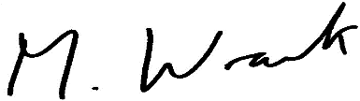

MATT WRACK
GENERAL SECRETARY

MW/jr

