Circular: 2018HOC0187AD

22 March 2018

TO: ALL MEMBERS

Dear Brother / Sister

NJC/3/18 – INCLUSIVE FIRE SERVICE GROUP - NATIONAL AWARENESS CAMPAIGN – A DEVELOPMENT IN ENGLAND: HOME OFFICE STATEMENT

This circular brings attention to NJC circular number NJC/3/18, “INCLUSIVE FIRE SERVICE GROUP – National Awareness Campaign – A Development in England: Home Office statement”, the content of which is self-explanatory.

Best wishes.

Yours fraternally
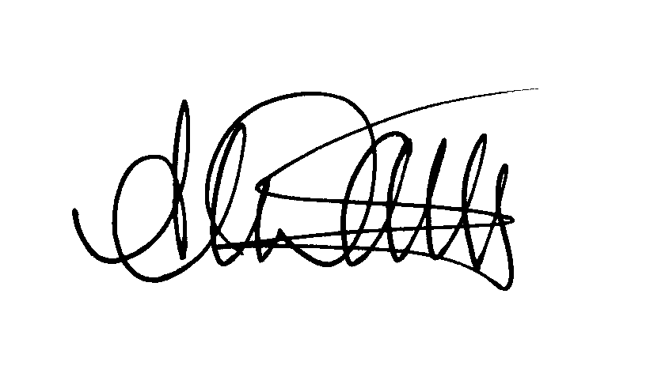
ANDY DARK
Assistant General Secretary

Attach.

AD/jh

