Circular: 2018HOC0140AD

«NameLine1» «RegionBrigade» «StationCode»
«OtherName»
«Address1»
«Address2»
«Address3»
«Address4»
«Address6»

26 February 2018

TO: All Members

Dear Brother/Sister

Firefighters, Former Firefighters and the European Union

The Fire Brigades Union recognises that there are approximately 3 million citizens from other countries in the European Union that live and work in the UK, it is also estimated that 1.2 million British migrants live in other EU countries. We note that there are members of our union that fall into both of these groups, i.e. we have FBU members who live in other EU states and also FBU members who were not born in the UK but who work here in fire and rescue services.
This situation is currently supported by Britain’s status as an EU member and the associated reciprocal rights of citizens whilst they are in EU states which includes accessing health care and the right to work and take up residence.
Since the referendum result on 23 June 2016, the future of UK citizens living in the UK and EU citizens living in the UK, including the FBU members in both categories, has been clouded by uncertainty. Politicians from all sides have cynically sought to use the status and future of such citizens as political bargaining chips. This is unacceptable.
The FBU, as agreed by Conference, opposed what has become known as Brexit. Since the referendum we await to see whether a Brexit deal is possible and what that deal looks like, whilst supporting all and any measures to protect jobs and workers’ rights. This includes supporting and promoting measures to ensure the rights of our all members and their families to a secure future.
Members who have been following Brexit negotiations closely will be aware of recent developments over the status of EU citizens in the UK but will also be aware of any discussions in this area being followed by the repeated exclamations of ‘nothing is agreed until it’s all agreed’ or ‘no deal is better than a bad deal’. As you can appreciate this won’t go far to allay the fears of our members who are awaiting confirmation of their status.
The purpose of this circular is to assure you that the FBU condemns the fact that our members, and the wider group of affected people, are being cynically used as a bargaining chip. Further, this circular re-affirms our commitment to supporting our members and their families’ right to remain in the country they choose to call home, to remain working in the UK fire service and to remain a member of our union. The references to time-limited protections for five years as contained in the EU-UK joint negotiators’ report dated 8 December 2017, fall far short of our expectations.
Contd/2….

-2-
We will use our influence to lobby as best we are able and have written to the Prime Minister to express our concerns. A copy of the letter to the Prime Minister is attached.
We shall continue to keep a close eye on Brexit negotiations and campaign to protect and support FBU members at home and at work.
Best wishes.

Yours fraternally
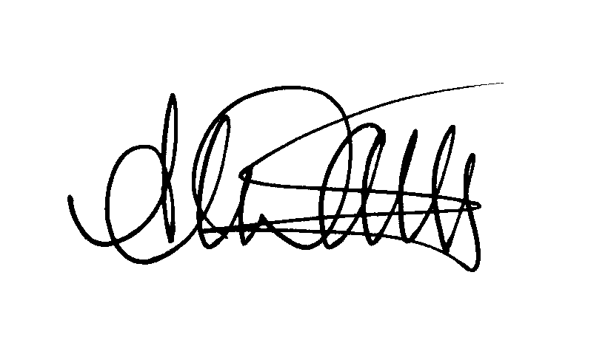

Andy Dark
Assistant General Secretary

Att.

AD/sll

