Circular: 2018HOC0134AD

22 February 2018

TO: All Members

Dear Brother/Sister

ECJ Judgment WTD and Firefighters

This circular brings attention to a recent finding by the European Court of Justice (ECJ), a link to which is provided below:

http://eur-lex.europa.eu/legal-content/EN/TXT/HTML/?uri=CELEX:62015CJ0518&from=EN

A brief summary of the background information is that this resulted from a case by Belgian firefighters who work an equivalent of our retained duty system.

Key points of the judgment:

1. Article 17(3)(c)(iii) of Directive 2003/88/EC of the European Parliament and of the Council of 4 November 2003 concerning certain aspects of the organisation of working time must be interpreted as meaning that the Member States may not derogate, with regard to certain categories of firefighters recruited by the public fire services, from all the obligations arising from the provisions of that directive, including Article 2 thereof, which defines, in particular, the concepts of ‘working time’ and ‘rest periods’.

2. Article 15 of Directive 2003/88 must be interpreted as not permitting Member States to maintain or adopt a less restrictive definition of the concept of ‘working time’ than that laid down in Article 2 of that directive.

3. Article 2 of Directive 2003/88 must be interpreted as not requiring Member States to determine the remuneration of periods of stand-by time such as those at issue in the main proceedings according to the prior classification of those periods as ‘working time’ or ‘rest period’.

4. Article 2 of Directive 2003/88 must be interpreted as meaning that stand-by time which a worker spends at home with the duty to respond to calls from his employer within 8 minutes, very significantly restricting the opportunities for other activities, must be regarded as ‘working time’.

Contd/2…

-2-

The Executive Council will be considering the implications of this and will keep members updated accordingly.

Best wishes.

Yours fraternally
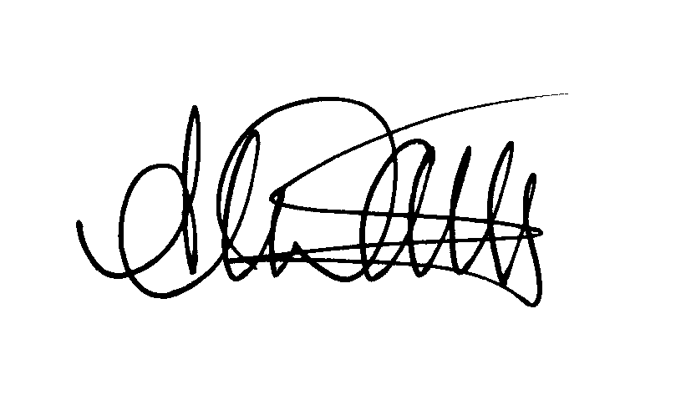

Andy Dark
Assistant General Secretary

AD/sll

