Circular: 2017HOC0643MW

8 December 2017

TO: ALL MEMBERS

Dear Brother / Sister

COVERT RECORDING OF MEETINGS AND CONVERSATIONS

Having been asked on an in principle basis as to the appropriateness of covert recording of FBU meetings, on 29 November 2017, the President issued Head Office circular number 2017HOC0621AMcL.

On 7 December 2017, at a meeting of the Executive Council, the intent of the circular was discussed and the following policy was agreed:

The covert recording of

- FBU meetings
- Conversations with or by FBU officials in that capacity
- Meetings between or involving FBU officials of any kind

is not to be undertaken by any member or official.

It was further agreed that this should be communicated to all members as an instruction from the Executive Council.

Accordingly, no member or official of the union should engage in the activity of recording any meeting or discussion in accordance with the policy, as agreed, above.

Best wishes.

Yours fraternally
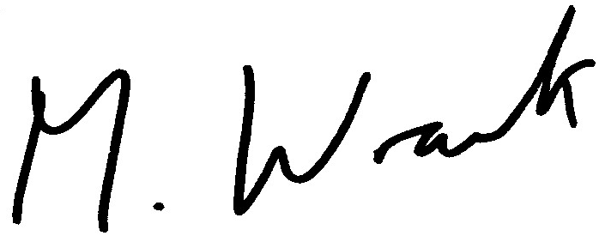

MATT WRACK
General Secretary

MW/jh

