Circular: 2017HOC0586MW

16 November 2017

TO: All Members

Dear Brother/Sister

Pay 2017

Members will recall from circular 2017HOC0518MW that the fire service employers had proposed that NJC pay rates should be increased by 1%. This was in response to the rejection of their previous proposals following a consultation with FBU members.

Following further dialogue with the employers and requests for clarification by the Executive Council, it has been confirmed that this proposal is not conditional on any other matters. Nor would it be considered as necessarily a final settlement of pay in relation to the current pay round.

As a result, the Executive Council agreed to consult members on this proposal and to recommend that the union should agree that NJC pay rates should be increased as suggested. This consultation will conclude at the December business meeting of the Executive Council (5-7 December). All branches should consider this proposal within this timescale.

Best wishes.

Yours fraternally

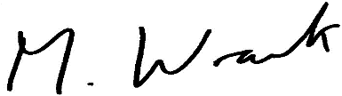

Matt Wrack
General Secretary

MW/sll

