Circular: 2017HOC0466AD

TO: ALL MEMBERS

31 August 2017

Dear Brother / Sister

DEATH OF MEMBER: BROTHER MARK HATTERSLEY

It is with much regret that I am informing you of the sudden and tragic death of our member Brother Mark Hattersley, who sadly died on Saturday 12th August 2017.

Mark was a highly regarded Firefighter in Avon Fire & Rescue Service and served on Blue watch, at Bedminster Fire Station. He leaves behind a wife, Rachael, and two young children. Everyone in the FBU sends Mark's family, friends and colleagues our full solidarity and support at this very sad time.

Mark's colleagues have set up a Just Giving page for donations. Please follow the link to support: https://www.justgiving.com/crowdfunding/james-britton-2

The funeral will take place on 8th September at 10:30 at St Bernadettes church on Wells Road, Bristol.

Local Fire Brigades Union officials are working with AFRS to offer support to Mark’s family, friends and colleagues.

Yours fraternally
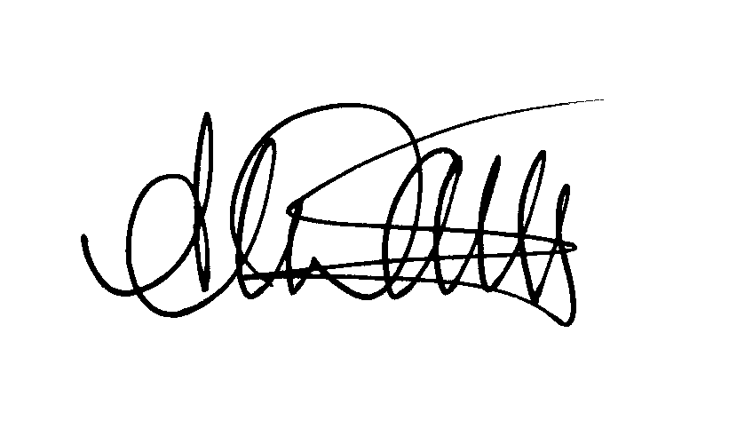
ANDY DARK
Assistant General Secretary

AD/jh

