Circular: 2017HOC0402MW

31 July 2017

TO: All Members

Dear Brother/Sister

Speech to Durham Miners’ Gala: 8 July 2017

The Durham Miners’ Gala is the biggest annual trade union gathering in the UK. The FBU regularly attends and I have had the privilege of addressing the event previously on behalf of our union. I was not scheduled to do so this year, however, the organisers, the Durham Miners’ Association, altered their plans in the aftermath of the Grenfell Tower disaster. Therefore, please find attached the text of the address I gave to the gala on Saturday 8 July. Footage of this is also available on the union’s Facebook page or at:

https://www.youtube.com/watch?v=vpJRjivXYNE

Best wishes.

Yours fraternally

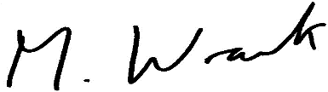

Matt Wrack
General Secretary

Att.

MW/sll

