Circular: 2017HOC0400MW

28 July 2017

TO: All Members

Dear Brother/Sister

Pay and conditions: employers’ response

As you will be aware, following the Executive Council earlier this week, we informed the fire service employers that their proposals on pay were unacceptable in the current form. Please find attached their response.

We will seek to discuss with the employers whether there is any change in their position and the Executive Council will need to consider the employers’ letter and any points made during discussions.

Best wishes.

Yours fraternally

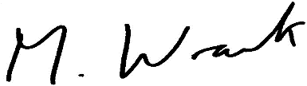

Matt Wrack
General Secretary

Att.

MW/sll

