Circular: 2017HOC0242AD

10 May 2017

TO: ALL MEMBERS

Dear Brother / Sister

NJC/06/17 – TECHNICAL WORKING GROUP – CO-RESPONDING AND WIDER WORK TRIALS

Please find attached a copy of the above NJC circular number NJC/06/17 and the associated surveys.

The issues under discussion at the Technical Working Group are hugely important to the membership, and to the union. The issues were identified in the University of Hertfordshire’s “Broadening responsibilities: Consideration of the Potential to Broaden the Role of Uniformed Fire Service Employees” report and have been reported by members and officials. They were also a key feature in the debate at recall conference held on 21 March 2017.

Though no substantive "products" have resulted from the Group's work at this time, it is clear to the FBU officials on the Group that the employers’ side is very receptive to the concerns and are committed to the process and to producing quality outcomes.

Further information will be provided in due course.

Best wishes.

Yours fraternally
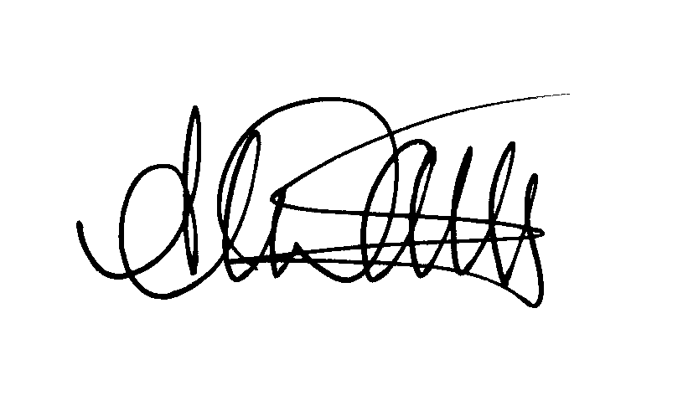
ANDY DARK
Assistant General Secretary

Attach.

AD/jh

