Circular: 2017HOC0223AD

«NameLine1» «RegionBrigade» «StationCode»
«OtherName»
«Address1»
«Address2»
«Address3»
«Address4»
«Address6»

21 April 2017

TO: ALL MEMBERS

Dear Brother/Sister

INDIVIDUAL PENSION QUERIES AND GENERIC PENSION POLICY ENQUIRIES

It is not uncommon for branch representatives and individual members to write to Head Office seeking information on developments in relation to fire service pension policy and/or seeking information and advice on an individual’s pension position.

As I am sure you will appreciate, it is an inefficient use of national officials’ time to respond to such enquiries; moreover, the union has a structure of three officials in each region and three officials in each brigade (there are specific arrangements in the singular-brigade regions: Northern Ireland; Scotland and London) who can, will and whose role is to deal with these matters.

In most instances the individual’s queries are of such a nature that these queries not only can be dealt with by our local officials but actually where they are best placed to do so because of their relationship with staff and officers of the fire and rescue service and the local pension administration providers.

Equally, information in respect of matters of pension policy and/or progression of pension initiatives are disseminated through to officials through the committee structures and/or via officials’ circulars. Local officials will be able to assist in providing information on those questions.

Where an official does not have the information available to him/her then the official will raise the query with Head Office as appropriate.

All officials – at whatever level of the union - are keen to ensure that members receive the advice that they want and need and progressing information requests via brigade and/or regional structures is by far the better route to ensure a quick response. Could I ask that members and branches raise any queries with local officials as that is the more appropriate and efficient route to raise the matter and to receive a response.

Many thanks.

Yours fraternally
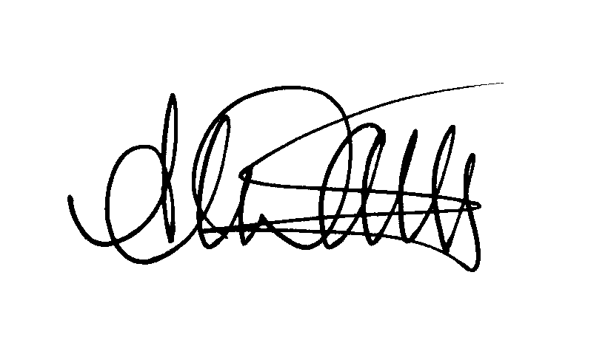
ANDY DARK
Assistant General Secretary AD/jh

