Circular: 2017HOC0128MW

To: All Members

Date: 23 February 2017

Dear Brother/Sister

Firefighters pay and the public sector pay freeze

The Executive Council discussed firefighters pay and the wider context of public sector pay at its February business meeting. This follows several meetings of the Executive Council’s Pay Group, which is the sub-committee tasked with developing our pay proposals. FBU conference in 2016 made it very clear that our members want pay very high on the union’s priorities for the foreseeable future. FBU officials have also taken part in TUC discussions, with a view to increased campaigning across the labour movement on pay.

Public sector pay restrictions

The economic downturn in 2007-08 saw attacks on workers’ pay across the UK economy, across much of Europe and in other parts of the world. Workers were forced to suffer for an economic crisis we did not create. There was no bail out for working people, but there has been an international drive to lower wages.

Public sector workers have been particularly hard hit. Over 5.4 million people work in the public sector – nearly 1 in 5 workers in the UK. The coalition government elected in 2010 imposed a two year pay freeze on public sector workers in 2011-12. This was followed by a 1% cap on the pay of firefighters, nurses, teachers, civil servants and other public sector workers.

In the Summer Budget 2015, the government announced that it will “fund public sector workforces for a pay award of 1% for four years from 2016-17”. With inflation once again expected to rise to 2-3% a year, this means that real term pay cuts could be in the region of 5-10% over the next four years until 2020.

Firefighters’ pay

The union has also commissioned research by Incomes Data Research, pay specialists used by the TUC and employers. We asked them to look specifically at firefighters’ pay. This research found that:

- Firefighters’ basic pay increases have been lower than the median pay settlement for the whole economy since 2006. A comparison with private sector pay settlements shows a similar pattern.

Contd/2…

-2-

- Compared with inflation, firefighters’ basic pay increases have been below inflation since 2007 on both the consumer price index (CPI) and retail price index (RPI) measures, with the exception of 2009 when RPI inflation was negative.

- In real terms, i.e. adjusted for RPI inflation, firefighters’ pay increases were negative throughout most of the period covered by the research (the exceptions were 2004, 2005, 2009 and 2015).

When wholetime firefighters’ basic salary levels were compared with those for a range of other associate professional occupations, they were mainly ahead of salaries for other roles such as paramedic, nurse, prison officer and civil servant. Control operators’ basic pay levels appear to be broadly ahead of those for similar jobs elsewhere, though this is not based on a matched comparison. Retained firefighters’ earnings are behind those for part-time employees in comparable occupations.

If the 2009 salary of £28,199 had been uprated by inflation in July 2010, then the competent wholetime firefighter rate would have reached £30,000 in 2011. If firefighters’ pay had been increased at a rate equal to inflation since 2010, then a competent wholetime firefighter would be over £5,000 better off if this was done using RPI and almost £3,000 better off if CPI was used.

Next steps

The FBU will develop a detailed pay claim for the NJC and MMNB meetings scheduled for June 2017. The union will launch a campaign, lobbying MPs and the employers, to explain how firefighters’ pay has fallen behind in recent years.

The FBU will continue to work with the other unions and the TUC on a ‘break the pay limit’ campaign. At the TUC in 2015, the FBU together with PCS, proposed measures for a major national joint campaign by unions against government pay policy. Unfortunately, despite the agreement of Congress, this has not yet been developed. We continue to make this demand at the TUC and elsewhere.

In the run up to our conference in May, the FBU will consult members via brigade committees and other channels in order to develop plans for wider campaigning on pay.

Best wishes.

Yours fraternally

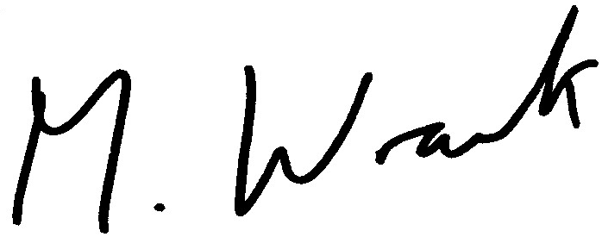

Matt Wrack
General Secretary

MW/sll

