Circular: 2016HOC0126AD

TO: ALL MEMBERS

21 February 2017

Dear Brother/Sister

NJC/01/17 – REPORT OF THE INDEPENDENT CHAIR
NJC/02/17 – INCLUSIVE FIRE SERVICE GROUP
NJC/03/17 – APPRENTICESHIP SCHEMES

Please find attached, a copy of NJC circular numbers NJC/01/17, NJC/02/17 and NJC/03/17, reporting some issues discussed at the meeting of the NJC/MMNB held on 14 February 2017.

Best wishes.

Yours fraternally
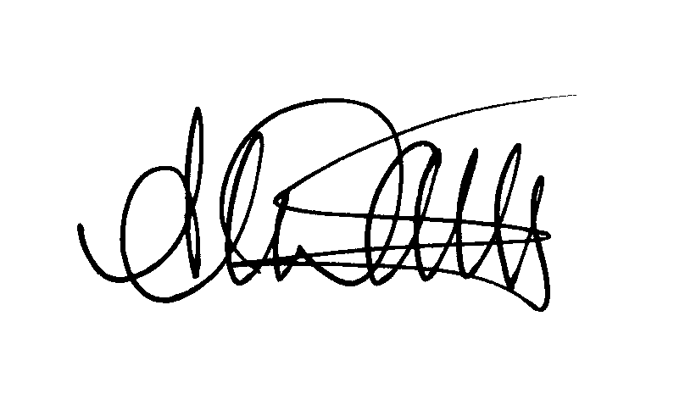
ANDY DARK
Assistant General Secretary

Attach. X3

AD/jh

