Circular: 2017HOC0035JM

Date: 23 January 2017

Dear Brother/Sister
INCLUSIVE FIRE SERVICE GROUP (IFSG) SURVEY

The FBU are playing a leading role in the National Joint Council (NJC) led Inclusive Fire Service Group (IFSG) which has been established to develop improvement strategies for the service on issues relating to equality. The group is carrying out a short survey to gather views of all staff and the FBU is very keen that our members participate in the survey.

Members may receive an invitation to complete the survey from their own service, if so please only complete the survey once. Below is a link to the survey which will be treated entirely confidentiality. Individual responses will not be shared with services and no one will be identified through the survey. Your views on how things can be improved are very important so please take the time to complete and submit your views to the survey.

The survey can be found here: http://survey.euro.confirmit.com/wix/p1855700622.aspx

Please respond at the earliest opportunity, or by 10th February 2017 at the latest.

Yours sincerely,
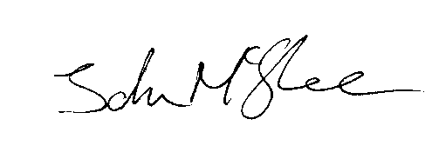
John McGhee
National Officer

JM/jr

