Circular: 2017HOC0031MW

«NameLine1» «RegionBrigade» «StationCode»
«OtherName»
«Address1»
«Address2»
«Address3»
«Address4»
«Address6»

To: All Members

Date: 19 January 2017

Dear Brother/Sister

Please show your support for North Yorkshire Firefighters

North Yorkshire FBU members are currently engaged in a lawful trade dispute with their employer over the intention to introduce Tactical Response Vehicles (TRVs) which would be crewed with only two or three firefighters. The intention of the employer is to mobilise these vehicles to a full range of incidents.

Following a successful ballot of FBU members, various forms of industrial action (short of a strike) have begun. This includes a refusal to ride the TRV with a crew of 2 or 3. Following the start of this action, the Chief Fire Officer has now begun to send FBU members home for the duration of the relevant shift. Various threats have also been made regarding possible disciplinary action. These steps have been taken by principal managers as a result of FBU members taking lawful industrial action following the registration of a lawful trade dispute and a vote by members. All our steps have been undertaken in accordance with legislation. I am sure you will share my concerns that an employer would nevertheless make such threats.

FBU members in North Yorkshire are standing up for professional standards and for the safety of firefighters and of the public. They deserve the support of all of us. Therefore could I request that you send messages of support to the FBU members at Scarborough Fire Station via Brigade Secretary Steve Howley at steve.howley@fbu.org.uk. Our members are now facing victimisation for taking lawful industrial action and for standing up to defend safety standards.

North Yorkshire FBU have set up a hardship fund account to assist those being financially penalised by the punitive actions of the CFO and I ask that donations are collected and made to the hardship fund from your members/committees in order to assist with any financial hardship our members in North Yorkshire are suffering.

Contd/2…

-2-

Hardship fund details:

North Yorkshire: North Yorkshire FBU Hardship Fund
Account number: 25450874
Sort code: 05-09-94

Best wishes.

Yours fraternally

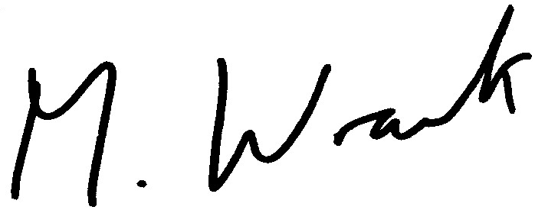

Matt Wrack
General Secretary

MW/sll

