Circular: 2016HOC0616MW

«NameLine1» «RegionBrigade» «StationCode»
«OtherName»
«Address1»
«Address2»
«Address3»
«Address4»
«Address6»

To: All Members

Date: 25 November 2016

Dear Brother/Sister

2018: Fire Brigades Union Centenary Year

Firefighters 100: Firefighters United

1 October 2018 will mark one hundred years since the founding of our trade union – a century of independent fire service trade unionism in the UK. We have already started to make various plans for the centenary and we want FBU members to be fully involved at local level.

FBU Centenary Project Aims

The Executive Council recently agreed the following key aims for the centenary project. These will provide a guide for consideration of national or local initiatives as we prepare for 2018:

- To promote and celebrate the work of firefighters and the fire and rescue service.

- To celebrate the union’s hundred-year history of independent firefighter trades unionism.

- To commemorate the bravery and sacrifice of those firefighters killed and injured in the line of duty.

- To celebrate the FBU’s role in the development of the firefighting profession, shaping the modern fire and rescue service and improving public safety.

- To celebrate the union’s work and achievements representing firefighters, campaigning for improvements, promoting fairness and equality and organising to defend our service, our jobs and working conditions.

- To celebrate the union’s contribution in the wider labour and trade union movement.

We are already in the process of planning various publications and events to celebrate our history during 2018.

Contd/2…
-2-

Firefighters 100: Firefighters United: We need your help

- Can you help us prepare for 2018?

- Do you have records, photos and memorabilia?

- Can you volunteer to get involved?

Our union was built by firefighters – often in very difficult circumstances. The history of our union is the history of those men and women on the frontline who have worked and campaigned to make local communities safe as well as to improve the conditions for our profession. We want to hear the voice of those on the frontline as part of developing our centenary project.

Please think how you might be able to assist. This might involve finding photos, letters, articles, reports, minute books or other records of local firefighters – including possibly of members of your family or of retired friends and colleagues.

It might involve organising local events or helping us to make direct contact with retired members.

If you have material which might assist us or if you want to volunteer to help please email centenary@fbu.org.uk.

Thank you for your help and support.
The past we inherit – the future we build.

Best wishes.

Yours fraternally

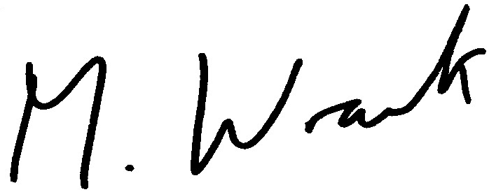

Matt Wrack
General Secretary

MW/sll

