Circular: 2016HOC0577MW

To: All Members

Date: 16 November 2016

Dear Brother/Sister

2015 Firefighters’ Pension Scheme: Transitional Protection Update November 2016
We have previously reported in various circulars, short films and via social media etc that the FBU is currently challenging government in relation to the transitional protection it introduced as part of imposing the 2015 Firefighters’ Pension Scheme. The listing timescale for our court is still January 2017 although as with all legal cases this may change.

We have also previously reported that there is a similar case in relation to the pension of judges which is slightly ahead of ours. The judges’ case is due to start on 14 November 2016 and is listed until 25 November 2016. We will be keeping a watchful eye on these proceedings and will report anything of significance that could affect our own challenge.

In relation to our challenge we have now completed an examination of all the documentation that has been submitted at this stage by the other parties. This has been a significant task involving a huge amount of information, emails, correspondence etc, contained in almost 50 large A4 folders.

We have also now finalised our initial witness statements on behalf of the FBU and will be submitting these later this week. These are only initial statements at this stage and can be updated or amended in response to any subsequent statement by the other parties.

Our legal team remain confident in our arguments, with the obvious caveat that there are no guarantees when dealing with the legal system and members will be updated regularly as things develop. Any updates will also be posted on the FBU website: www.fbu.org.uk.

Best wishes.

Yours fraternally

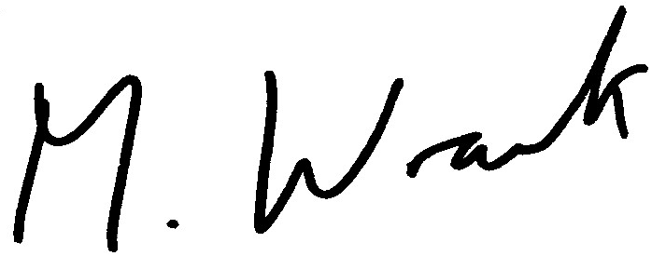

Matt Wrack
General Secretary
MW/sll

