«NameLine1» «RegionBrigade» «StationCode»
«OtherName»
«Address1»
«Address2»
«Address3»
«Address4»
«Address5»

Circular: 2016HOC0562DG

24th June 2016

To: ALL MEMBERS 7 November 2016

Dear Brother/Sister,

FBU ONLINE SHOP

I am pleased to inform you that the FBU has launched a new online shop.

You can browse and make purchases from the shop via: https://shop.fbu.org.uk/.

This site is the only place to get official FBU merchandise all year around. Through the shop we aim to supply high quality, value for money and ethically sourced FBU merchandise to our members and supporters at the click of a button.

The shop has been stocked with a wide range of FBU promotional gifts including t-shirts, hip-flasks, cuff links, mugs and beanies. As a launch special gift, for a limited time only, every order will also receive a free FBU card holder.

At this stage the shop is still being developed, additional lines will be added in the coming weeks and months, including clothing for children, retirement gifts and various other promotional goods. There will also be an opportunity at a later stage to customise some lines of clothing to your specific region or brigade.

You can pay for products from the shop with all major credit and debit cards.

If you have any queries about the shop or any feedback, please do not hesitate to send them to shop@fbu.org.uk.

2017 Diaries

The 2017 Slimline Diary (in black only) is available from the FBU shop and will only be sold via this method. The diary is priced at £5, plus p+p. Orders should be made as soon as possible to ensure early delivery.

2017 Calendars

The FBU are also producing a calendar for 2017, and this will be available via the FBU shop shortly. The photos used in the calendar will be the 12 commended entries into the FBU photo competition that took place earlier this year. The calendar is priced at £7.50, plus p+p.

Contd / …….

In the run up to Christmas, you can purchase both the 2017 diary and calendar (along with a free FBU pen) for just £10.

Many thanks.

Yours fraternally,
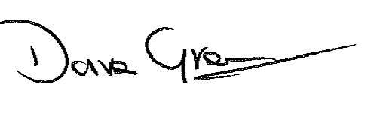
DAVE GREEN
National Officer

DG/kc

