Circular: 2016HOC0557MW

«NameLine1» «RegionBrigade» «StationCode»
«OtherName»
«Address1»
«Address2»
«Address3»
«Address4»
«Address6»

To: All Members

Date: 4 November 2016

Dear Brother/Sister

Oldham Street, Manchester: Incident July 2013
The death of Brother Stephen Hunt – FBU report and work so far

There is no more serious matter for the Fire Brigades Union than the death of a member in the line of duty. Our service deals with hazardous situations every single day, but our members and their families have the right to expect that firefighters will return home safely from work. That is why, over many decades, the union has made every effort to help the service and governments learn the lessons from major incidents, especially from those where lives have been lost.

The FBU has produced a 90 page report explaining our concerns arising from one particular tragedy: the death of Brother Stephen Hunt. Stephen was a member of the FBU in Greater Manchester and was killed attending the fire in Oldham Street, Manchester, on 13 July 2013. The FBU is proud to have counted Stephen as a member. Stephen’s death was a tragedy that could have been prevented. It is a tragedy that must never be repeated.

A hard copy of this report has been sent to every fire station in the UK, FBU officials, to fire and rescue authorities and to Chief Fire Officers.

FBU officials from the North West Region and from GMC worked tirelessly and professionally to make sure that the inquest into Stephen’s death was aware of all the FBU concerns as well as ensuring that members involved in this incident were fully represented whenever necessary.

This report, including an introduction from myself, is broken down into six main sections:

- A submission the FBU made to the inquest outlining to the senior coroner that previous recommendations relating to incidents where firefighter fatalities had occurred could be linked to this incident and raising concerns that lessons had not been learned.

- The full Regulation 28 report from the senior coroner Mr Meadows including 10 matters of significant concern.

- The FBU submission to the Home Secretary which analysed each of these concerns and provided an example of a previous similar recommendation made in relation to earlier firefighter fatalities.

Contd/2…
-2-

- The government response to the Regulation 28 report from Mr Meadows suggesting that the majority of the concerns can be addressed by reviewing and amending existing guidance via the National Operational Guidance programme.

- A further letter from the FBU to the Home Secretary outlining serious concerns about the limitations of this approach.

- Conclusion and next steps outlining that this issue will be raised with all officials and members as the union engages on a campaign in relation to firefighter safety.

The FBU is arranging a lobby of Parliament in Westminster on 29 November 2016 which will include issues relating to this incident and to firefighter safety and professional standards. Details of this lobby will be circulated shortly. Please make every attempt to support this lobby.

The FBU is also preparing a series of briefings and bulletins relating to this incident, firefighter safety and our ongoing drive towards professional standards and training for firefighters.

These documents which will be distributed shortly can be used to raise our concerns in all forums. All these documents will be available on the FBU website www.fbu.org.uk.

We must ensure that the lessons from Stephen Hunt’s death are learned and safety measures are implemented.

Every FBU member can get involved by:

- Joining the union’s campaign.
- Insisting that safety is made a priority.
- Demanding safety training.
- Reporting incidents, near misses and other concerns.
- Discussing safety matters at work.
- Lobbying politicians locally and nationally.

FBU officials will be directed to:

- Raise the coroner’s report with principal managers.
- Ensure there are FBU safety reps on every branch.
- Organise an active health and safety committee in the brigade.
- Mobilise members to take up safety matters.
- Engage with principal managers on health and safety policy and enforcement.

I am sure that we all recognise that the union can never back down when the safety of our members is at stake.

Best wishes.

Yours fraternally

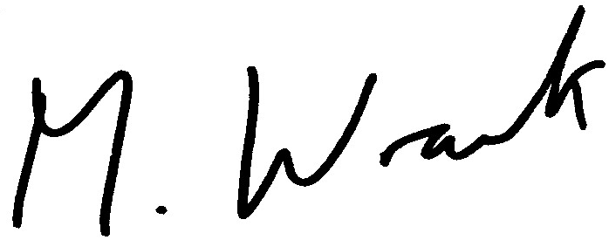

Matt Wrack
General Secretary

MW/sll

