«NameLine1» «RegionBrigade» «StationCode»
«OtherName»
«Address1»
«Address2»
«Address3»
«Address4»
«Address6»
Circular: 2016HOC0556AD

3 November 2016

Dear Brother/Sister

HOME OFFICE PUBLISHES THE THOMAS REVIEW

The Home Office has today published the Thomas Review which it commissioned in August 2014 and which Adrian Thomas submitted to DCLG in spring 2015. The FBU submitted a written response to the Review which was reported to members in March 2015. You can view our submission on the following link :
https://www.fbu.org.uk/circular/2015hoc0186ad/fbu-submission-dclg-thomas-review

The 93 page document with 45 recommendations is a compendium of ill-informed notions, which in many cases are contradictory and in all cases un-researched. As we reported when the review was first initiated, it is quite simply a hatchet job on firefighters and the fire and rescue service.

The report can be found on this web link:
https://www.gov.uk/government/publications/conditions-of-service-for-fire-and-rescue-staff-independent-review

A profile of Adrian Thomas can be found in this web link:
https://uk.linkedin.com/in/adrianthomasuk

This circular brings the publication to members’ attention. The circular does not attempt to begin to deconstruct the document. The union is currently finalising a critique of the content of the report should the Home Office seek to have the recommendations implemented, and we will be seeking information regarding the Home Office’s intention accordingly.

We have today issued a press release which is attached to this circular. Members will be kept informed of developments.

Best wishes.

Yours fraternally
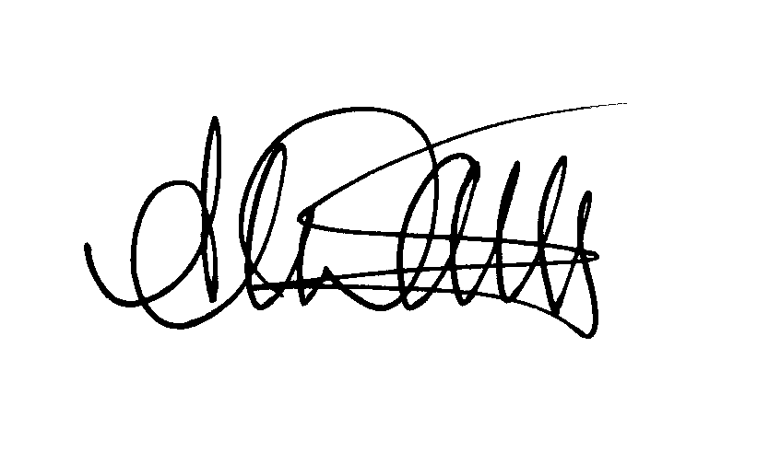
ANDY DARK
Assistant General Secretary

Attach.

Fire Brigades Union press release
Thursday 3 November 2016
For immediate release

THOMAS REVIEW PAINTS AN UNRECOGNISABLE PICTURE OF THE FIRE AND RESCUE SERVICE, SAY FIREFIGHTERS

The Adrian Thomas review into working conditions of the fire and rescue service, published today, some 20 months after its completion last year, is incompetent, irrelevant and misleading, according to the Fire Brigades Union (FBU).

The firefighters’ union always had doubts that the review was truly ‘independent’, and these concerns have deepened following the appointment of the review’s author Adrian Thomas as a government advisor. He is now Deputy Director of the Cabinet Office.

Andy Dark, assistant general secretary of the FBU, said “This review was initiated at a time when tensions between the government were at breaking point, when the dispute over firefighters’ pensions was at its height. The review focuses heavily on a pre-conceived notion that the fire service is rife with bullying, which is far from the truth. Thomas’s section on bullying and harassment paints a picture of a fire and rescue service few firefighters - 85% of all firefighters are FBU members - would recognise. We conducted our own YouGov survey of more than 10,000 firefighters into bullying and harassment over the same period as part of our submission to the review - yes, bullying was a factor of working life but the majority of it was being inflicted on firefighters by fire service management, which is something the review avoided totally.”

Commenting on the fact that the review was completed 20 months ago, Dark, himself a former firefighter of 25 years standing, added:

“This review has no relevance for the fire and rescue service, which probably explains why it is has taken almost two years to publish. Its author has no understanding whatsoever of the fire sector, and he clearly made scant effort to gain a grounding in the basics of fire and rescue before writing his review. He fails totally to grasp the massive change that has taken place in the industry, not taking in the expanding role of firefighters to areas such as emergency medical response (EMR), flood rescue or any other work areas currently being progressed. He was a very poor choice of author, and his so called ‘findings’ are incoherent.”

The Thomas Review supports the proposals for Police and Crime Commissioners (PCCs) to run fire and rescue services. The FBU is clear there is no evidence whatsoever to suggest the move will bring any improvements at all to the service and would simply bring disorganisation and inexperience into the governance of fire and rescue services. Dark added: “The review advocates measures which will bring further fragmentation of the service, something which has been criticised by many, including the coroner who recently considered the causes of the death of firefighter Stephen Hunt in Manchester. We know that centrally co-ordinated and nationally agreed professional standards with consistent terms and conditions are the way forward for a professionally run service – Thomas’s review flies in the face of common sense and professionalism at every turn.”

“Our hope is that this report, initiated when the fire service came under Department for Communities and Local Government (DCLG) will be seen for what it is. The Thomas Review is an ill-conceived report, a distraction which has the potential to be counter-productive to the current work being undertaken to expand the role of the fire and rescue service”.

Ends

