Circular: 2016HOC0445AD

Date: 25 August 2016

To: All Members

Dear Brother / Sister

DEATH OF MEMBER: BROTHER PAUL WILKENS

It is with great sadness that I write to inform you of the death of Brother Paul Wilkens, a member from Castle Donington station in Leicestershire.

Brother Wilkens was found passed away at his fire station on the morning of 23 August 2016.

Paul was 47 and leaves a partner and four dependant children.

The appropriate enquiries are being made in to the circumstances of this tragic event.

Local officials and colleagues have set up a JustGiving account to assist in a collection for Paul’s family. The details are :

https://www.justgiving.com/crowdfunding/Paul-Wilkens

I know you will join me in expressing sincerest condolences to Paul’s family, friends and colleagues.

Yours fraternally
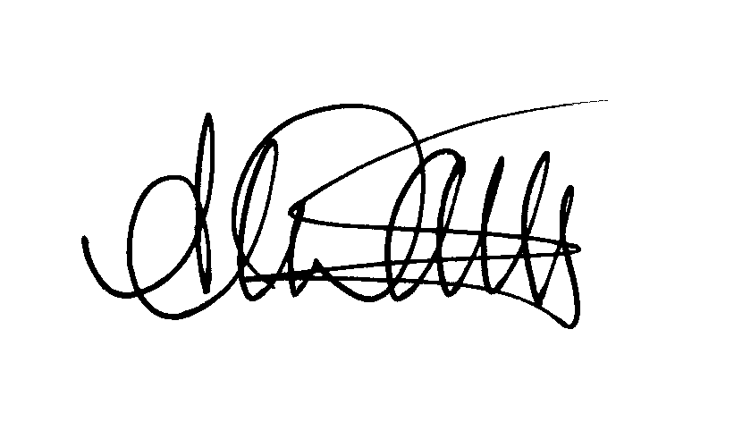
ANDY DARK
Assistant General Secretary

AD/jh

