Circular: 2016HOC0392JM

2 August 2016

Dear Brother/Sister

NJC CIRCULAR - NJC/9/16
Attached is a copy of the most recent circular from the National Joint Secretaries.

This circular gives a brief update on some of the work being carried out by the Inclusive Fire Service Group and includes a copy of guidance issued to Fire and Rescue Services on the personal use of social media.

The Union will be providing support to local officials who may be involved in the development of local
policies.

I trust you will find this information useful.

Yours sincerely,
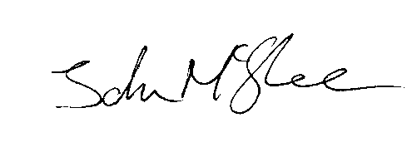
John McGhee
National Officer

JM/jr

