Circular: 2016HOC0317MW

21 June 2016

Dear Brother/Sister

PENSIONS: LEGAL CHALLENGE: AGE DISCRIMINATION 18-20

You will be aware that the FBU has successfully challenged the government in relation to age discrimination relating to members who joined the 1992 firefighters’ pension scheme before age 20. This is more commonly known as the ‘18-20 claim’.

The FBU had challenged government through a ‘part 8’ claim which is a much simplified legal route for dealing with an issue that just requires a legal determination on an interpretation of the law. Both parties agreed a question to be posed to a judge.

At the eleventh hour however, the Secretary of State took a decision not to defend the government position and to accept the FBU position in relation to this. The remedy to this was drawn up in a legal document which was signed by both parties. This agreement stipulated that the 1992 scheme rules would be amended within 6 months to allow the remedy to be enacted.

To date, this legislation has not materialised and the Home Office is in breach of the agreement in relation to the 6 months’ timescale. We have been in contact with Home Office officials on a number of occasions raising concerns around the delay. On the afternoon of Friday 10 June, the union received a letter from the Home Office, setting out the proposed remedy and requesting an early agreement to the proposals.

This proposal did clarify that the government had accepted an argument that the FBU had provided, to include within the remedy, members who transferred in service from another scheme (such as armed forces pension) which contributed to them achieving the 30 years maximum pensionable service prior to age 50.

/Cont….

2.

The FBU responded on 13 June pointing out that the Home Office was already in breach of the order, and that FBU members had not received the remedy they were promised within the agreed timescale. The letter also suggested that any further delays would result in our returning to court. A follow up letter from Home office was received on 17 June. This letter outlines that the Home Office is finalising the necessary regulations which will be shared with us shortly, and that they are keen to avoid any further delay.

We will be monitoring this closely and will keep members informed of any developments.

Best wishes.

Yours fraternally
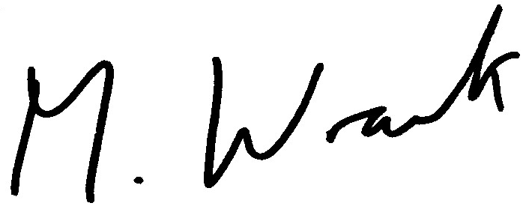

MATT WRACK
General Secretary

MW/jh

