Circular: 2016HOC0217JM

6th May 2016
To: All Members

Dear Brother/Sister,

SWITCH TO DIRECT DEBIT

You may be aware that the government’s proposed trade union bill has been amended to allow unions to continue using check-off. This however is on the condition that unions pay 'reasonable' costs.
At this time there has been no information on what reasonable cost may be.

The union is continuing to switch members onto direct debit as the preferred means of paying union subscriptions. Those members who have not yet completed a direct debit form are encouraged to do so as soon as possible.

Those members who have already submitted and moved onto direct debit should not cancel this as it may not be possible to move back to check-off at this time.
If members have any questions relating to this issue they should contact their brigade official before taking any action. Direct debit mandate forms and check off cancellation forms are available at https://www.fbu.org.uk/Switch2DD

Yours sincerely,
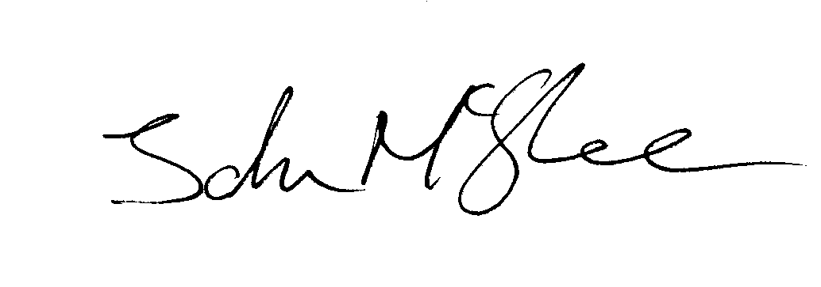
John McGhee
National Officer

JM/jr

