Circular: 2016HOC0179JM

To: ALL MEMBERS
5th April 2016

Dear Brother/Sister,

SWITCH TO DIRECT DEBIT – WIN AN iPAD MINI

As you will know the Westminster government is introducing a Trade Union Bill which takes away the ability for local government workers, including those in the Fire and Rescue Service, from paying directly from their wages.

As a consequence, we have been being forced to change the way our members in Scotland, England and Wales pay their union subscriptions.

Many members have already made the switch to Direct Debit, which ensures that their membership and benefits remain protected. It is essential that all members make this switch.

If you have not yet completed a Direct Debit mandate form, please do so as soon as possible. You can download the forms from https://www.fbu.org.uk/Switch2DD, or contact your local officials who will be able to supply one.

Please do not forget to complete the check off cancellation form, which will allow us to then do this on your behalf.

All those members who have returned a completed Direct Debit mandate form by 29th April 2016 will be entered into a prize draw. The prize for the April draw will be an iPad Mini (donated by UIA Mutual Home Insurance).

Don’t delay – Switch today!

Yours sincerely,
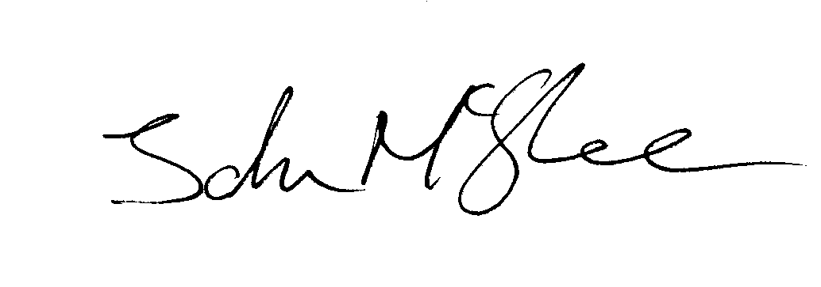
John McGhee
National Officer JM/jr

