Circular: 2016HOC0164MW

17 March 2016
To: ALL MEMBERS

Dear Brother/Sister

National insurance increases from April

State pension changes and the end of contracting out of state second pension from April 2016

From April 2016, changes are being implemented to the state pension and to national insurance arrangements which will once again hit the majority of FBU members in their wage packet. These changes, which are yet another attack on pension schemes, will mean an increase in state pension age. They also mean an increase to national insurance contributions for many employees and employers, including five million public sector workers.

Details on the new state pension and an explanation of the full changes can be viewed in various formats on the Department for Work and Pensions (DWP) website:

https://www.gov.uk/yourstatepension

It is important to note that the changes affect people differently since they are based on your national insurance (NI) contribution record.

The amount you will receive and the age you will receive it at, is also based upon your individual circumstances. You can access your state pension statement by following the link above and clicking on ‘get a state pension statement’. If you are in any doubt on how you are affected by these changes you should get a state pension statement.

End of contracting out

A key change is the ending of contracting out of state second pension which will impact on how much members of the Fire Service pension schemes pay in NI contributions. Firefighters can expect to pay an extra 1.4% in NI contributions from April 2016. (Please note, however, if you decided not to join or if you opt out of the Fire Service pension schemes you will still pay this higher NI contribution).

However this is presented, it will ultimately mean a pay cut to the majority of firefighters who have already faced severe pay restrictions and increased pension contributions over recent years. Employers will also be hit by this decision as ending contracting out means they also lose a NI rebate worth 3.4%. This will add further pressure to local Fire and Rescue Services.
Contd/2….

-2-

What is contracting out?

A more detailed explanation on contracting out and how it will affect you, including a video, is available via the link below:

https://www.youtube.com/watch?v=SJNsjGHPHeU

In simple terms:

- Currently in addition to the basic state pension, the state provides a second-tier top-up pension, based on how much you earn.

- Eligible employees, including members of the Fire Service pension schemes, are currently 'contracted out' of this additional pension.

- In return they have so far paid lower National Insurance contributions.

- Instead they received extra pension from their occupational scheme or personal/stakeholder pension.

- This was the incentive to encourage people to leave the state earnings-related pension scheme (SERPS).

How are the rules changing for contracting out?

Contracting out ends in April 2016, when the Government’s state pension changes come into force.

How will this affect me?

Until April 2016, if you are contracted out you pay a reduced rate of National Insurance. This is based on you getting a contracted out NI rebate of 1.4% for employees. When the new single state pension is introduced in April 2016, contracted out NI rebates will cease. This change will affect most FBU members.

The usual employee National Insurance contributions are applied using a banded approach. Details on all the bands are available on the Government rates and allowances webpage.

https://www.gov.uk/government/publications/rates-and-allowances-national-insurance-contributions/rates-and-allowances-national-insurance-contributions

Unfortunately but not unsurprisingly Government have continued to ignore calls to rethink their decision ending contracting out and the changes are set to be implemented next month. These measures are a part of the wider austerity agenda and will lead to more than five million public sector workers (and others) suffering a further tax increase which will reduce take home pay as well as add further pressure for cuts in our service.

Best wishes.

Yours fraternally,
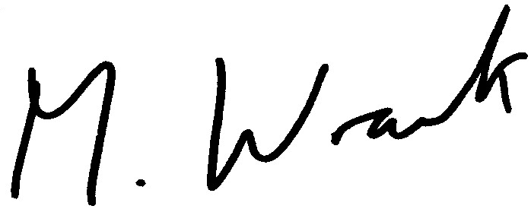

MATT WRACK
General Secretary

MW/sll

