Circular: 2016HOC0156MW

15th March 2016
To: ALL MEMBERS
cc: Executive Council Members
National Retained Committee

Dear Brother/Sister,

ELECTION OF NATIONAL RETAINED COMMITTEE CHAIR

In the election for National Retained Committee Chair, the Scrutineers have declared the result of the ballot as follows:

National Retained Committee Chair
Our independent scrutineers (Popularis) report of voting in the above election, which closed at 2pm on Monday 14th MARCH 2016, is as follows:-

Number of ballot papers dispatched: | 8601
Number of ballot papers received: | 932
Number of papers found to be spoilt/invalid: | 1
Result (1 to elect):-

Brother John CATHERWOOD 495 ELECTED

Brother Paul REVILL 436

The ballot papers will be stored securely for a period of twelve months before being destroyed.

I am therefore pleased to declare that Bro. Catherwood is elected as National Retained Committee Chair.

Best wishes.

Yours fraternally,
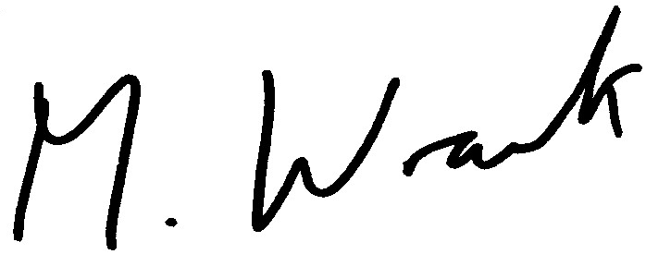
MATT WRACK
GENERAL SECRETARY

MW/DG/jr

